 

Examining the Aesthetics of Friction Stir Welded Mokume Gane

*Prepared by:*

Eric Olson

*Faculty Advisors:*

Dr. Michael West

REU Site Director, Department of Materials and Metallurgical Engineering

Dr. Barat Jasthi

Research Scientist

Dr. Alfred Boysen

Professor, Department of Humanities

*Program Information:*

National Science Foundation

Grant NSF #0852057

Research Experience for Undergraduates

Summer 2011

South Dakota School of Mines and Technology

501 E Saint Joseph Street

Rapid City, SD 57701

**TABLE OF CONTENTS**

1. Abstract
   1. Objectives
   2. Findings
2. Introduction
   1. Background
   2. Objectives
   3. Developmental Plan
3. History
4. Broader Impact
5. Procedure
   1. Materials
   2. Equipment
   3. Procedures
6. Results
   1. Physical
   2. Aesthetic
7. Conclusion
8. Future Work
9. Acknowledgments
10. References

**Abstract**

Mokumè ganè, a traditional, decorative metalworking technique of Japan has seen a significant revival in the last half-century as the process was rediscovered. This solid-state process utilizes diffusion bonding to join dissimilar metals without adhesive or solder. The resulting layered metal was used for decorative purposes. Another, more recently developed solid-state process is Friction Stir Processing (FSP). This is also a technique for joining metals together; however, this technique has been used for purely industrial purposes. The purpose of this study is to examine the aesthetic properties of metals that have undergone FSP and, specifically, the effect of FSP on mokumè ganè. Brass-copper mokumè ganè was successfully created through the course of this study, and it was found that this mokumè ganè could be successfully Friction Stir Processed. Distortions formed by the stirring process were clearly visible in the thicker plates. Additional research is required to determine what additional effects repeated stir processing and hot work would have on the patterns formed.

**1. Introduction**

Mokumé gané is a decorative Japanese metalworking technique developed in the early 18th century. It is a diffusion bonding process used to join dissimilar metals together. The metals can then be cold worked to form various patterns. Often the resulting pattern resembles wood grain, giving mokumé gané, or literally “wood-eye metal,” its name.

A more modern method of joining metals together is friction stir welding. This technique is also used to join metals without liquefying them. However, because of the advanced equipment required to perform this process, and the excellent mechanical properties of the bond, this process has remained confined to the realm of industry and research.

**2. History**

The development of the first mokumé gané is attributed to Denbei Shoami (1651-1728) a master smith from Akita prefecture. He bonded copper and shakudo (a Japanese gold-copper alloy) together and made decorative sword guards for samurai, who at that point had gained significant social clout. However, because of Japan’s reclusive nature at this time, the rest of the world would not know of the technique’s existence for another 100 years, when the days of the samurai had nearly ended. The only report that was available in the west incorrectly identified soldering as the method for joining the plates together, and while efforts to use this technique were made, using this technique proved to be ultimately futile.

In the 1970s James Binnion and others rediscovered the traditional diffusion bonding method for creating mokumé gané. This led to a resurgence in interest in the craft that effectively saved what was a dying art. Over the last few decades, modern technology has allowed for much greater control over the bonding process and combined with a better understanding of physics, has allowed for metal combinations that would have been impossible in the days of the samurai.

**3. Broader Impact**

While the reasons behind the importance of art to society are beyond the scope of this report, it is generally agreed that the arts are important to a healthy society. Art can be both expressive and informative. In this case, this project will primarily inform. Ideally, this will be a new breakthrough in the field of decorative metalwork.

This project may also act as a stepping stone for other artists, who may not be familiar with the details of FSP. Few painters concern themselves with the organic chemistry to understand how pigments interact with each other. However, those who do concern themselves gain a unique understanding of their medium. In the same way, this project will allow metal artists to both understand a mysterious aspect of their craft, diffusion bonding, and learn a new technique that can be applied to future work. While this project may not directly generate dramatic new artworks, hopefully the process described will inspire other metal artists to take advantage of new techniques to create revolutionary works.

Another possibility is for mokumè ganè to generate superior marker studies, clearly showing where the metal flows in the nugget, without the difficulties involved in using stacked plates. Because the plates are bonded under extremely clean conditions, the friction bond is likely to be free of defects due to contaminants. These can also be used as teaching tools, as much of the flow is visible to the naked eye.

**4. Procedure**

**Materials**

C110 Copper O60 (soft / annealed) temper

C260 Cartridge Brass

Aerosolized Boron Nitride

Acetone

Distilled Water

240 Grit Sandpaper

**Equipment**

Lindberg/Blue Electric Furnace

Ultrasonic Bath

Friction Stir Welder

Clamping Press (Small Billet)

Clamping Press (Large Billet)

Rolling Mill

Friction Stir Welder

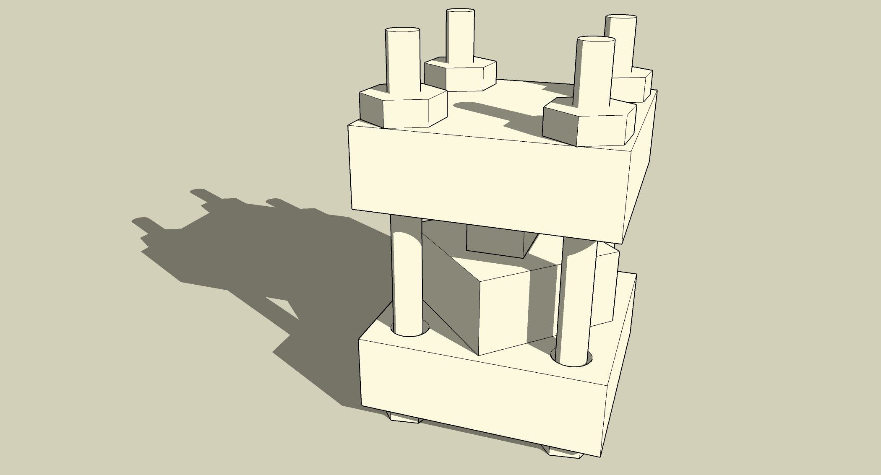

Figure 1: Assembled Clamping Press (Small Billet)

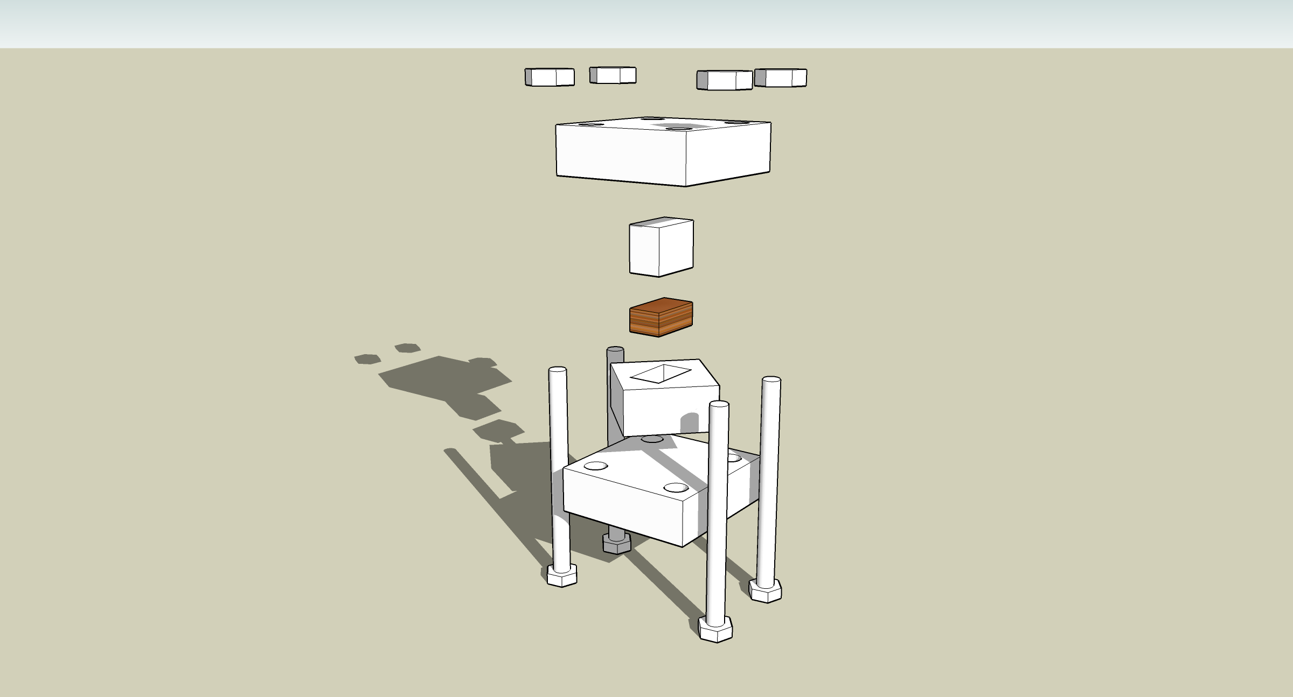

Figure 2: Press Components (Small Billet)

**Procedures**

Before diffusion bonding can occur, both surfaces to be joined must be extremely clean. The surface preparation technique used was primarily sanding the surface with 240 grit sandpaper and rinsing with distilled water. The abrasion broke up and removed oxides that had formed on the surface and the roughened the surface, increasing the area available to bond. This process also appeared to encourage mechanical bonding as the interface was made jagged at the microscopic level (see figure 3). The distilled water also acted a float for any contaminants removed. Surgical gloves were worn throughout the surface preparation process to also limit contamination by oils in the skin.

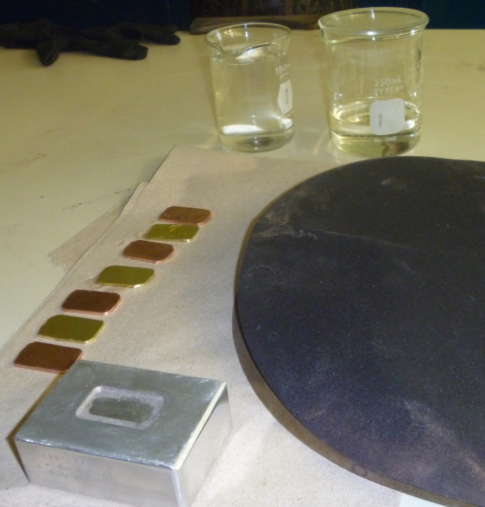

Figure 3: surface preparation setup

Before the cleaned plates were transferred to the press, the press was coated with a layer of boron nitride, a high temperature, chemically inert release agent. Then, after the plates had been inserted into the press and the press was assembled and tightened, the entire assembly was wrapped in stainless steel tool wrap and the resulting bag was filled with granulated charcoal. This was to prevent oxidation from destroying the bond while in the oxidizing atmosphere of the electric furnace.

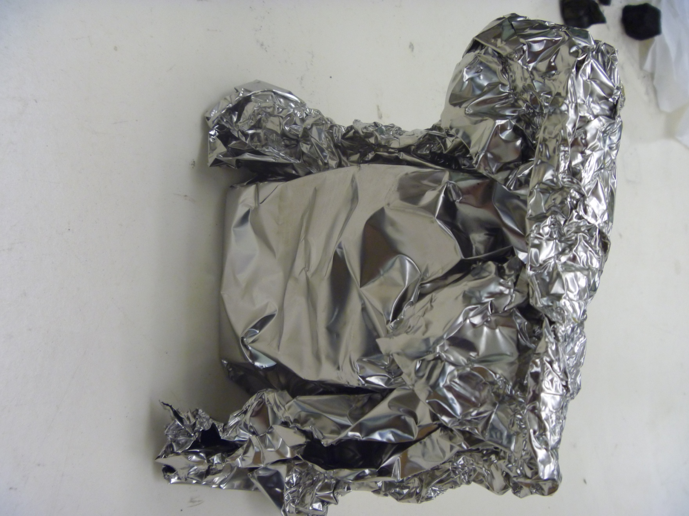

Figure 4: Wrapped press (small billet)

The three major components of diffusion bonding are time, pressure, and temperature. The method used for this project is relatively low temperature (approximately 200 C to 100 C below the melting point any metals used). Because pressure is not necessarily controlled, time and temperature must but carefully monitored.

For the first brass-copper bond, a temperature of 700 C was used, as recommended by Ian Ferguson in his guide to mokumè ganè. A time of 2 hours was used. When this process was complete, a bonded billet was formed. This billet was cut open to reveal the internal structure of the billet and confirm that bonding had taken place. Cutting this billet with the wet saw caused multiple delaminations. This was likely due to impurities that had not been removed by the cleaning process and had weakened some of the bonds. However, the portions of the billet that did not break were mounted and microhardness measurements were taken.

For the second billet, additional measures were taken to ensure that bonding was achieved. An acetone pre-soak was used in addition to the previously mentioned cleaning technique. Once cleaned, the billet was heated to 725 C for 2 hours and 30 minutes. Despite these additional measures, the second billet was incapable of being cold worked and delaminated very easily. Both hammering and cold rolling were attempted before nearly all the layers of the billet had delaminated.

At this point, a discussion with James Binnion revealed that brass-copper mokumè ganè could withstand significantly higher temperatures of 800 to 850 C without risking melting. However, a risk that would be encountered at this temperature would be the vaporization of the zinc in the brass. He also stated that from personal experience that brass-copper mokumè ganè was not suitable for cold work. He was also concerned that the lack of a perfectly level press surface could reduce the quality of the bond, although the quality of the presses used in this project made that concern possibly unjustified.

The third billet used a temperature of 788 C, as the furnace was used concurrently with an extended heat treatment by another REU student. The billet appeared to have completely bonded, and hot rolling was attempted at 700 C. This, however, also caused delamination, and extreme bowing of the billet. Like the second billet, the delamination is likely due to the extreme shear stress caused by the rolling mill. Also, the small mass of the billet likely caused it to cool rapidly, and rolling likely occurred at a lower temperature than intended. To circumvent these difficulties, a new press was constructed that could contain a larger billet. The billet formed by this new press would be over 3 times larger than the previous billets and be large enough to allow for friction stir processing without any rolling.

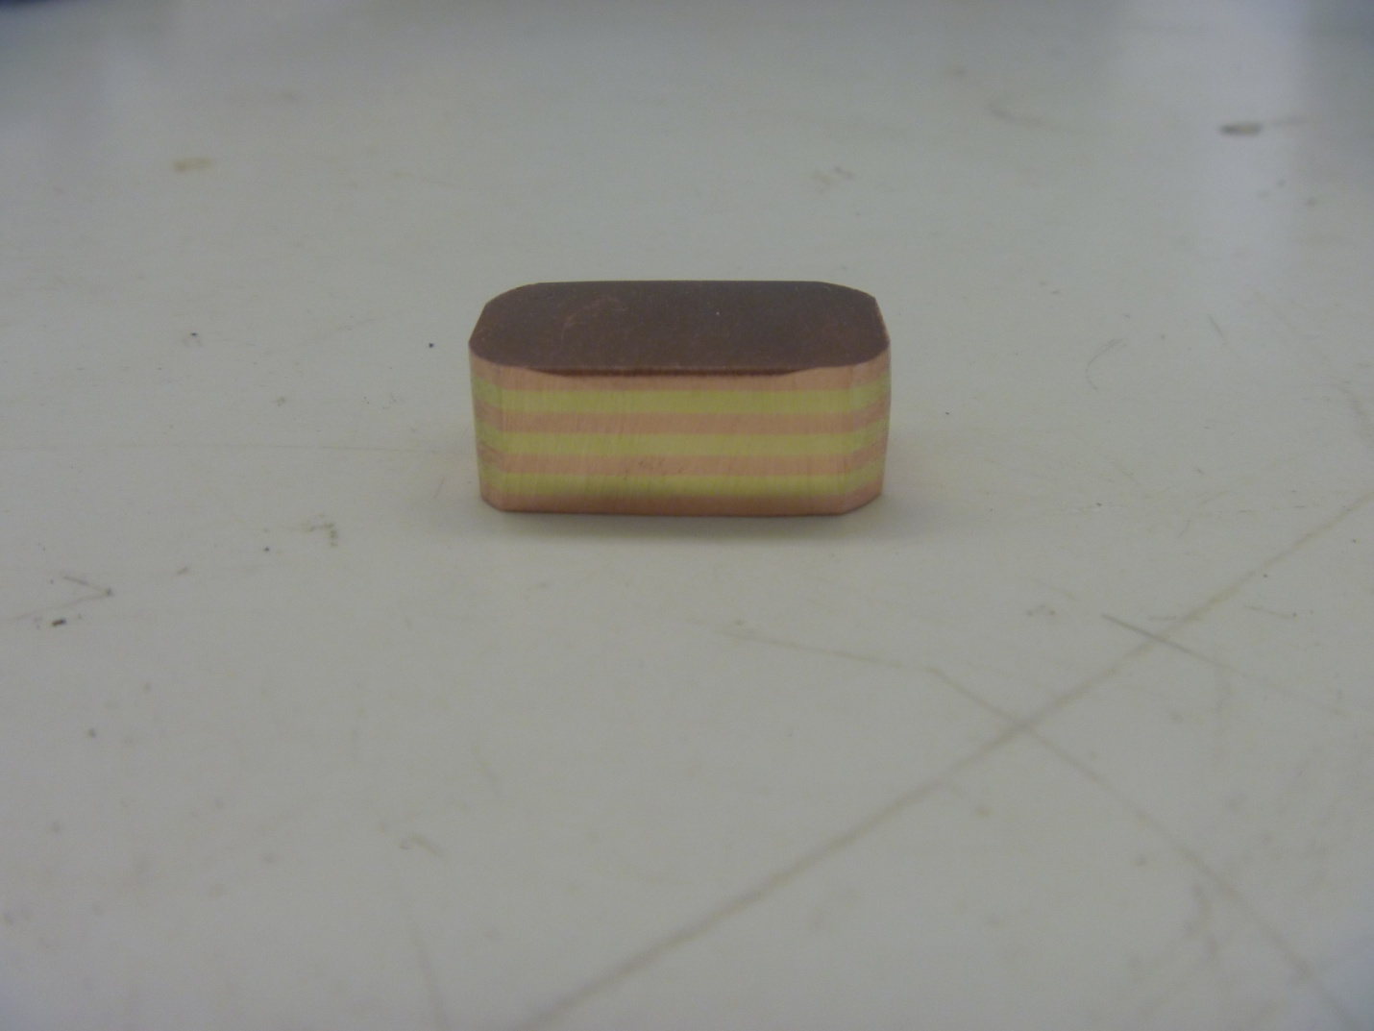

Figure 5: mokumè ganè billet 3

This new press operated on the same principles as the original press, with generally larger components. The billets used in this press also were given a ten minute ultrasonic bath afterwards to remove any particles remaining from the sanding process.

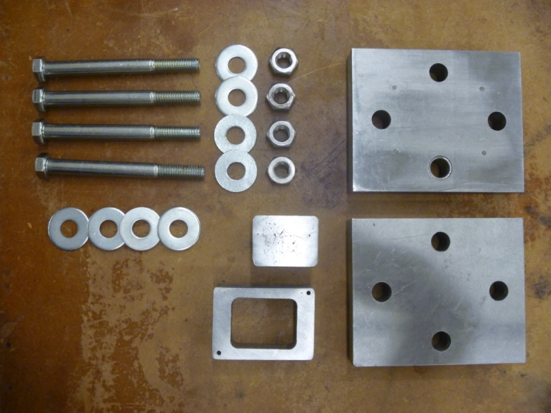

Figure 8: disassembled clamping press (large billet)

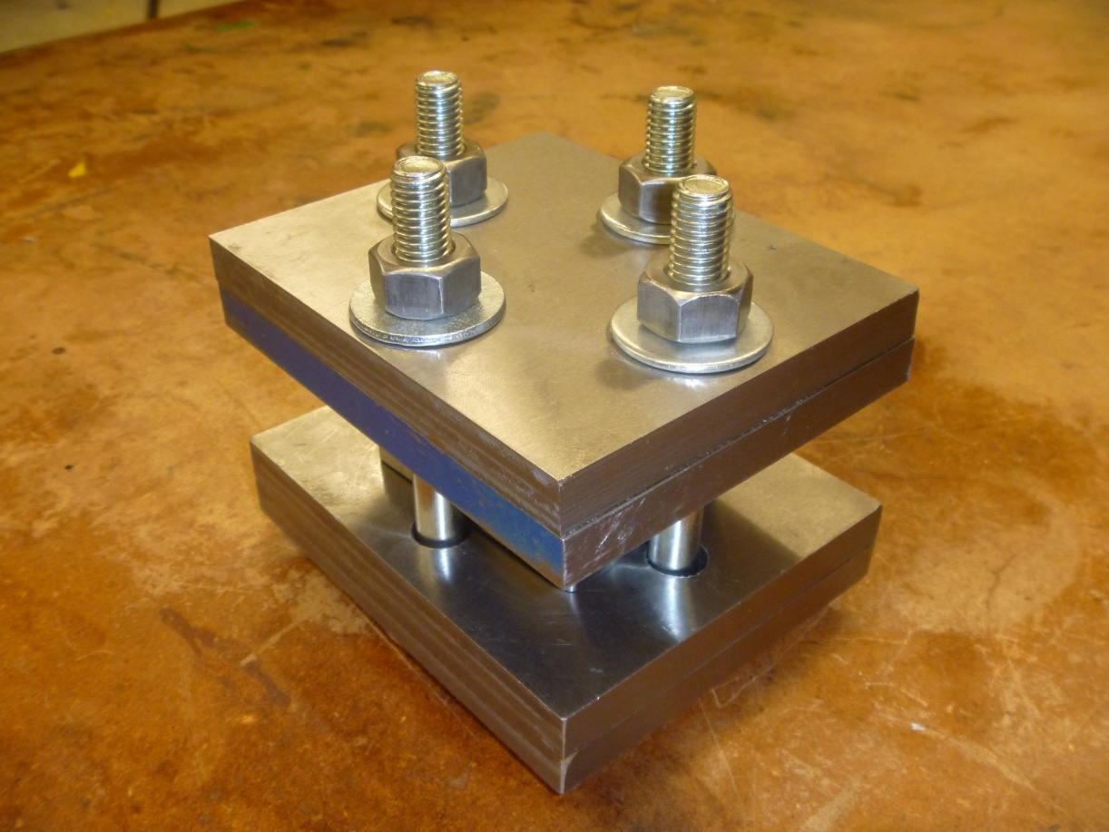

Figure 6: assembled clamping press (large billet)

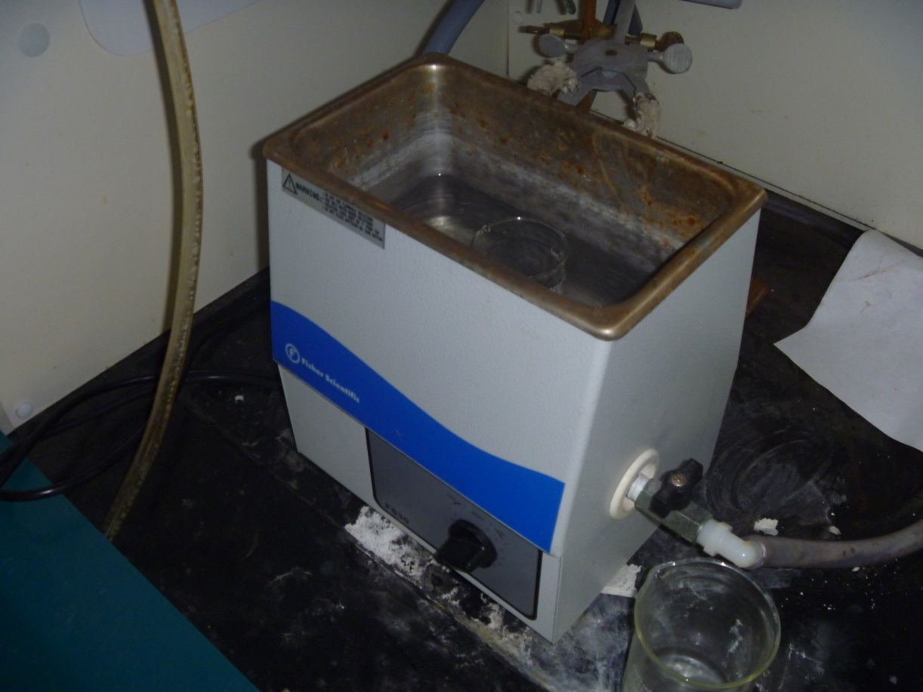

Figure 7: ultrasonic bath

Two additional billets were made using this technique. Both were heated to 825 C for two and a half hours. The first of these two suffered a brief temperature drop that did not appear to affect the billet. The second, when complete, left a residue that appeared to be brass on the inner walls of the press. Because this was the last billet made, a reduced amount of boron nitride was used to determine how much release agent was necessary to prevent components from adhering to each other. While the vast majority of components were not affected by this, the bolts used seized, and had to be cut off using a grinder.

Both were plunge welded using Friction stir processing. The remaining loose plates (many of them too thin to be of practical use in the production of the billets) were Friction Stirred at this point.

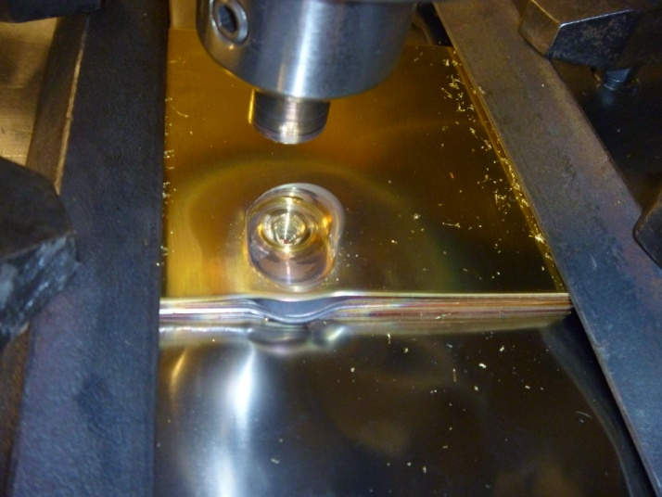

Figure 8: Friction Stirring loose plates

**5. Results**

**Physical**

The first billet resulted in what appeared to be an effective bond, with nominal bonding between all layers. However, when the billet was cut to examine the internal structure, delamination occurred at two of the interfaces between layers. This may have been due to stress on the billet rather than poor bonding, as brass residue was present on the delaminated copper layers. Mirohardness readings taken on the cut sample are shown below in table 1.



Table 1: Microhardness Readings for Billet 1

Despite additional measures taken to ensure total bonding, the second billet was incapable of being cold worked and delaminated very easily. It was at this point that contact with James Binnion revealed that brass and copper, while not difficult to bond, was not suitable for cold work. As such, the third billet was hot rolled; however, this also caused delamination, although this may have been due to the small amount of mass of the billet allowing it to cool rapidly before and during rolling.

At this point, the large press was build to allow Friction Stir Welding directly on the billet. The two billets made were both plunge welded. This process invariably broke the diffusion bond on the surface layer. This break led to the conclusion that Friction Stir Processing puts significantly more stress on the surface layers of the metal that the lower ones. In one case, the process also cracked the second layer as well; this may have been the result of a weak bond. However, the remaining layers appeared to remain completely bonded. When the cross-sections were cut and examined, no noticeable defects were found, and the stress imparted by the wet saw caused no damage to the billet.

**Aesthetic**

The billets formed, while not easy to work, had a unique appearance. The unchanged parallel layers had a minimalist beauty when polished that was more that durable enough for decorative purposes. When friction stir welded, the multicolored impression left on the surface of the billet was visually interesting, but was also unwieldy and overly complicated from that view. Slicing the billet open, however, yielded different deformations that could easily be sculpted or formed into unique and unusual patterns. When the second Friction Stirred billet was examined, it was apparent that the both the weld nugget had become more homogenized and the distortions in the billet had been reduced. However, while the cross-section was less visually appealing that the first billet with one weld, the surface indent contained a visually striking mass that had been twisted and forced into the void created by the first weld.

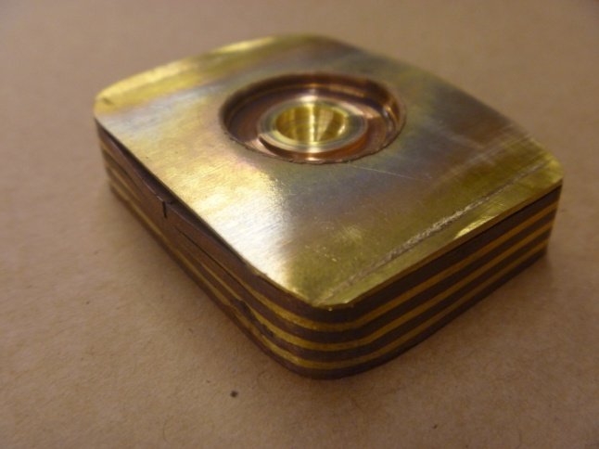

Figure 7: plunge welded billet

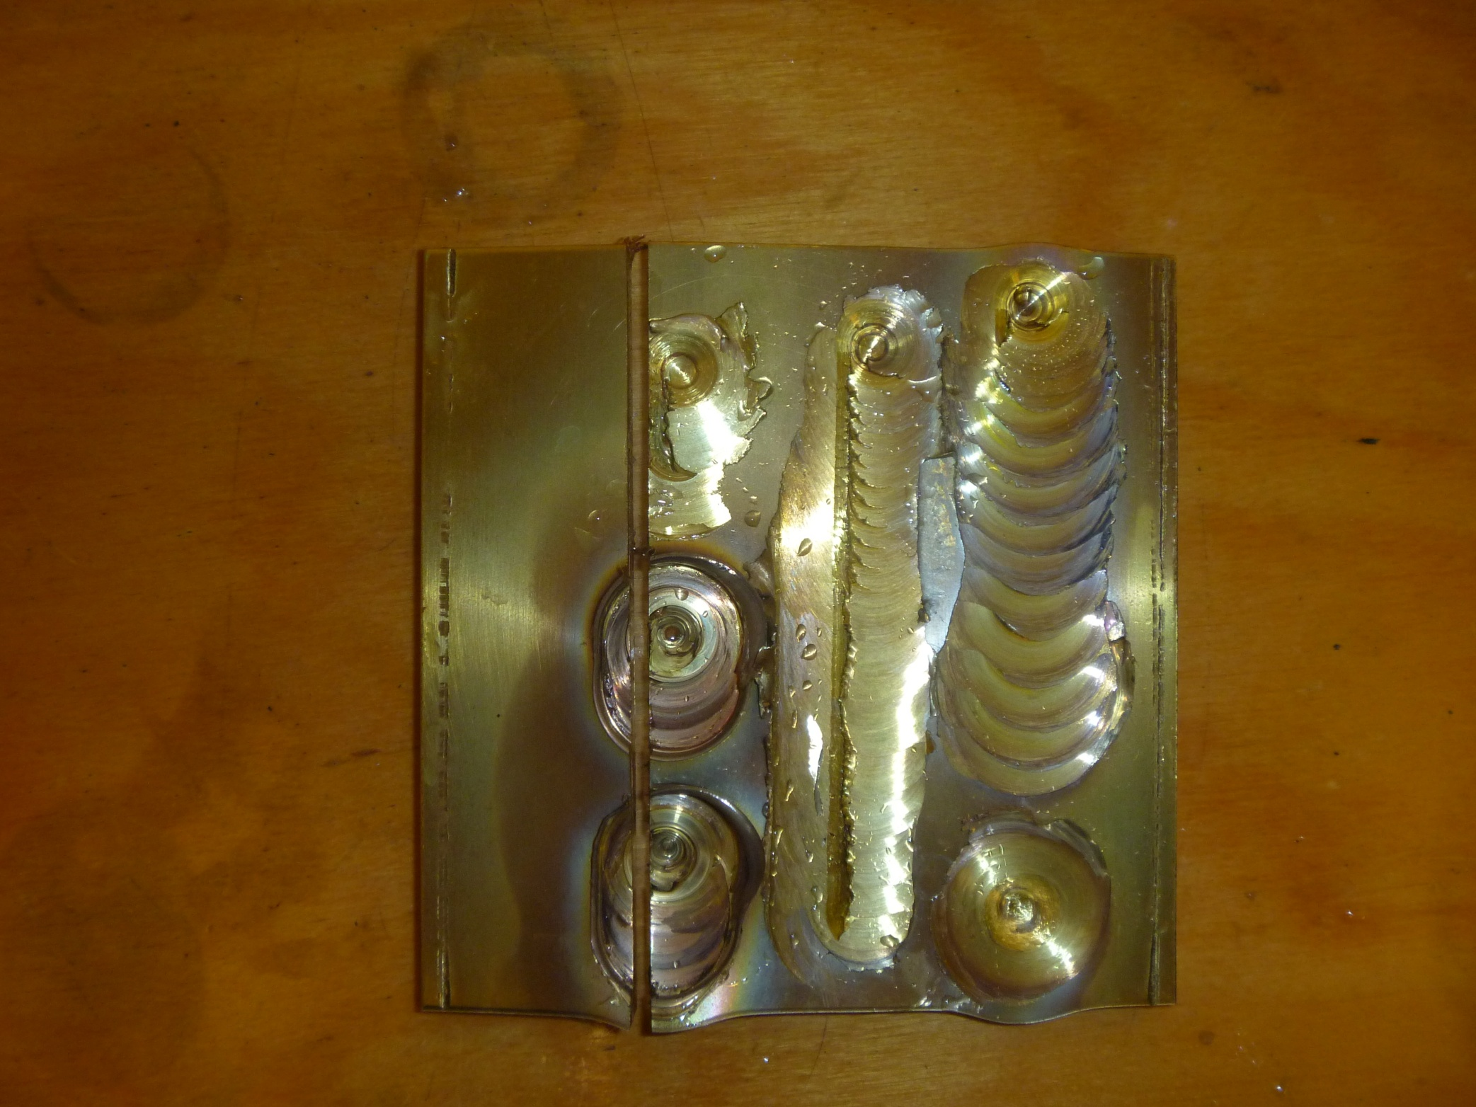

Figure 8: Stir welded plates

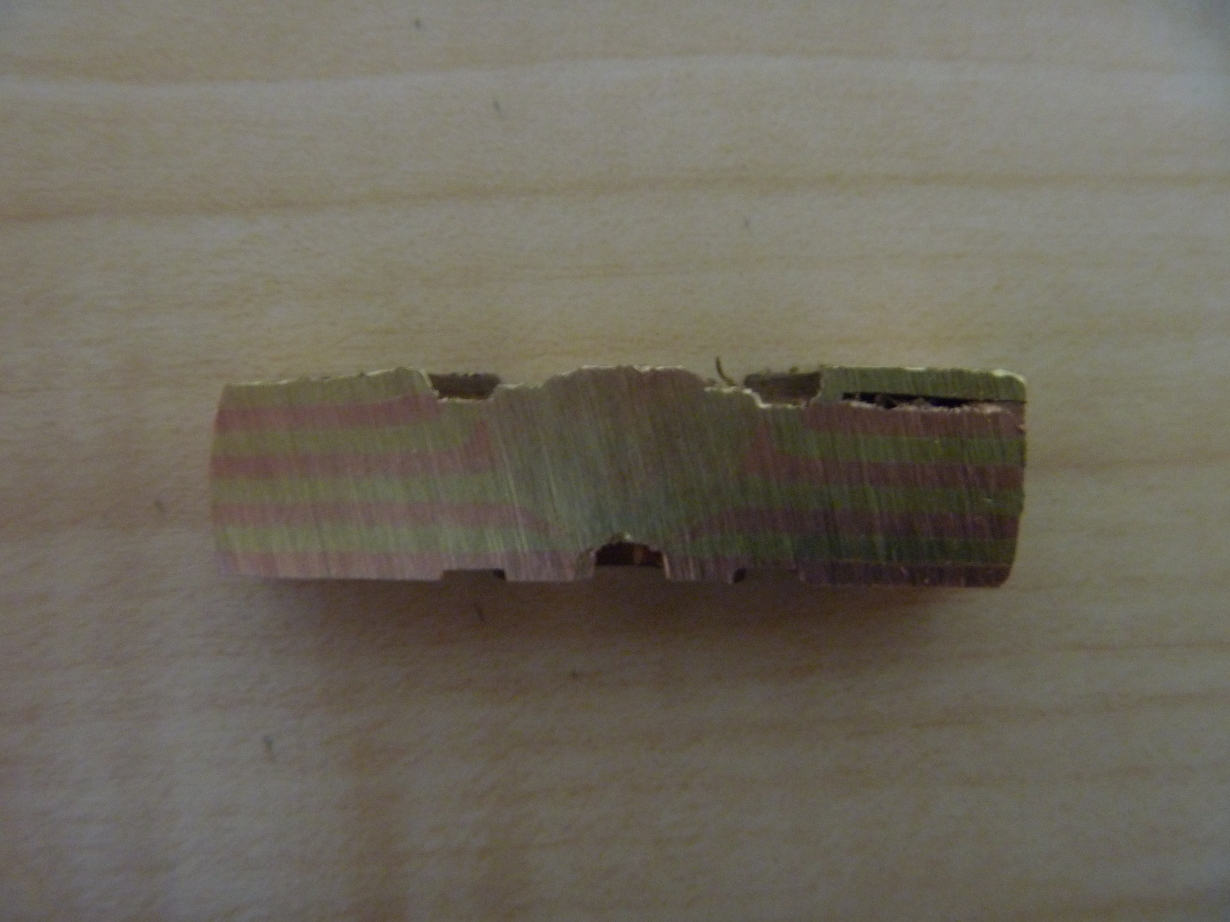

Figure 9: Double Stir Welded Billet

**7. Conclusion**

This project led to many conclusions. A major conclusion is that brass-copper mokumè ganè is not well suited to create the traditional wood grain effect of mokumè ganè. However, the color contrast is strong, and the materials are cost effective compared to precious metal alternatives. Thus, while copper-brass mokumè ganè is suitable for some applications, further research should be done with a more workable metal combination. It is clear that Friction Stir Processing is effective as a patterning tool in mokumè ganè, albeit limited in scope. A major issue is that Friction Stir Processing mixes the layers of the mokumè ganè, eliminating some potential patterns. Another limiting factor is the minimum size that can be processed, as this method may be impractical when working with precious metals, especially if the pattern desired is only found in a select region of the billet.

When working with unbonded plates, larger regions were processed. These welds made clear that most visually interesting distortion occurred near the edges of the weld. This showed that the most distortion with a minimum of mixing occurred during the plunge welds. Therefore, it is advisable to perfom multiple plunge welds in different areas rather than cover an area with one linear weld. Also the thinner plates showed very little distortion, being completely consumed by the nugget.

One item that warrants additional study is the color formed by the nugget. Because it is a mixture of the two layers, a slightly different shade of color was formed. Patinas may help bring out this midtone and make mixed regions desirable.

**8. Future Work**

There is much potential for future work in this area, as there appears to have been no prior attempts to Friction Stir Process mokumè ganè. The first area to examine would be the appearance of different metal combinations under friction stir welding. This would benefit from a better understanding of the microstructure of mokumè ganè. Also, the effect of various patinas, especially on the Friction Stirred region, would be examined.

One of the most significant areas where additional work could be performed is in perpendicular welds, or welds on mokumè ganè that has already been processed by more traditional techniques. Machining out various patterns near the weld could also highlight the three dimensional nature of the pattern. In all cases, more mechanical testing should be done to quantify the strength and durability of the bond, both before and after patterning.

**Acknowledgments**

The funding for this research came from the National Science Foundation. Special thanks to Dr. Alfred Boysen . Thanks to REU site director Dr. Michael West for his support and dedication to the REU program, Ian Markon, for invaluable help in sample processing and preparation. Special thanks to AMP center staff, John Franklin, Tim Johnson and Todd Curtis for their expertise and assistance, and the rest of the AMP center team for their enthusiastic help on this project.

**References**

1. Ferguson, Ian. *Mokume Gane*. 1st ed. London: Krause Publications, 2002. Print.
2. Binnion, James, and Bryan Chaix. "Old Process, New Technology: Modern Mokume Gane." n. pag. Web. 27 Jun 2011. <http://mokume-gane.com/documents/SantaFePaper.pdf>.
3. Binnion, James. "Designing, Building and Testing a Thermal Expansion Mismatch Torque Plate (TEMTP) System for Diffusion Bonding Mokume Gane Billets: "The Poor Man's Hot Press"." *The Santa Fe Symposium on Jewelry Manufacturing Technology*. Eddie Bell: Albuquerque, NM, Met-Chem Research. 2005. 65-102. Print.
4. Weisner, Klaus. "Sintering Technology for Jewellery and Multicolor Rings"." *The Santa Fe Symposium on Jewelry Manufacturing Technology*. Eddie Bell: Albuquerque, NM, Met-Chem Research. 2005. 501-20. Print.
5. Binnion, James. Telephone Interview. 07/19/2011.